

Department of Computer Science

MY University, Islamabad.

**Implementation Phase (LAB)**

**Project No: 08**

**Course Title: Database System**

**Student Name: Taha Saddiqui**

**Registration No: baib232005**

**Batch: Fall2023**

**Program: Ai**

**Semester: 6th**

**Lab Instructor: Mr. Hamza Javed**

**Submission Date: 10/06/24**

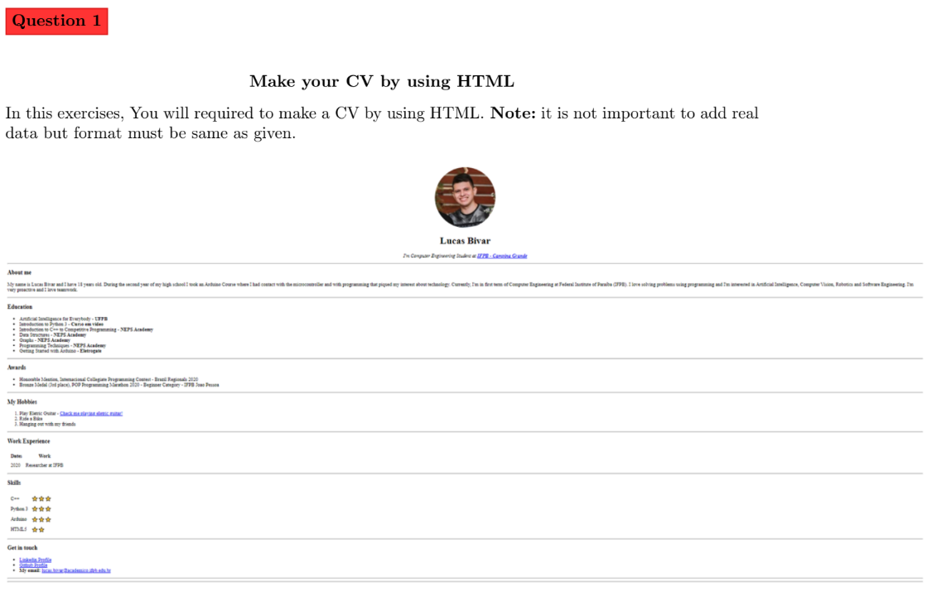

<!DOCTYPE html>

<html lang="en">

<head>

 <meta charset="UTF-8">

 <title>Taha Saddiqui Site</title>

</head>

<body>

 <center>

 <div style="width: 200px; height: 200px; border-radius: 50%;

overflow: hidden; display: flex; align-items: center; justify-content: center;">

 <img src="tahadp.jpg" alt="Taha profile picture"

style="width: 100%; height: auto;">

 </div>

 <h1>Taha Saddiqui</h1>

 <p><em>I'm an Artificial Intelligence Student at <strong><a

href="https://myu.edu.pk">MY University</a></strong></em></p>

 </center>

 <hr>

 <h3>About me</h3>

 <p>As a passionate student studying Artificial Intelligence, I am excited to bring my programming skills and knowledge to the world of AI and web development. With a strong foundation in programming languages and a hunger for learning, I am always eager to take on new challenges and push boundaries. My biggest achievement includes completing a Full Stack Developmental Project, which has equipped me with hands-on experience in building web applications from the ground up. My best quality is my eagerness to learn and develop; my top skills include programming, problem-solving, and collaboration.

 </p>

 <hr>

 <h3>Education</h3>

 <ul>

 <li>SSC |

 2017 – 2019

 Graduated With 'A' Grade. <strong>HN Science school MUltan</strong></li>

 <li>HSSC |

 2019 – 2021

 Graduated With 'D' Grade. <strong>City college of Science & Commerece Multan</strong></li>

 <li>BS Artificial Intelligence |

 2021 – Currently Studying. <strong>MY University Japan Road,

Islamabad</strong></li>

 </ul>

 <hr>

 <h3>Awards</h3>

 <ul>

 <li>Student of the Year - 2018</li>

 </ul>

 <hr>

 <h3>My Hobbies</h3>

 <ol>

 <li>Computer Hardware & Software Projects - </li>

 <li>Travelling</li>

 <li>Coin Collection</li>

 </ol>

 <hr>

 <h3>Work Experience</h3>

 <table cellspacing="10">

 <thead>

 <tr>

 <th>Dates</th>

 <th>Work</th>

 </tr>

 </thead>

 <tbody>

 <tr>

 <td>2024</td>

 <td>Python Developer Intern at OctaNet</td>

 </tr>

 </tbody>

 </table>

 <hr>

 <h3>Skills</h3>

 <table cellspacing="10">

 <tr>

 <td>C++</td>

 <td> &#11088; &#11088; &#11088; &#9734; &#9734; </td>

 </tr>

 <tr>

 <td>Python </td>

 <td> &#11088; &#11088; &#11088; &#11088; &#9734;</td>

 </tr>

 <tr>

 <td>HTML</td>

 <td> &#11088; &#11088; &#11088; &#9734; &#9734;</td>

 </tr>

 <tr>

 <td>Java</td>

 <td> &#11088; &#9734; &#9734; &#9734; &#9734; </td>

 </tr>

 </table>

 <hr>

 <h3>Get in touch </h3>

 <ul>

 <li><a href="https://www.linkedin.com/in/taha-saddiqui440"> Linkedin

Profile</a></li>

 <li><a href="mailto:baib232005@myu.edu.pk">Email</a></li>

 </ul>

 <hr>

</html>

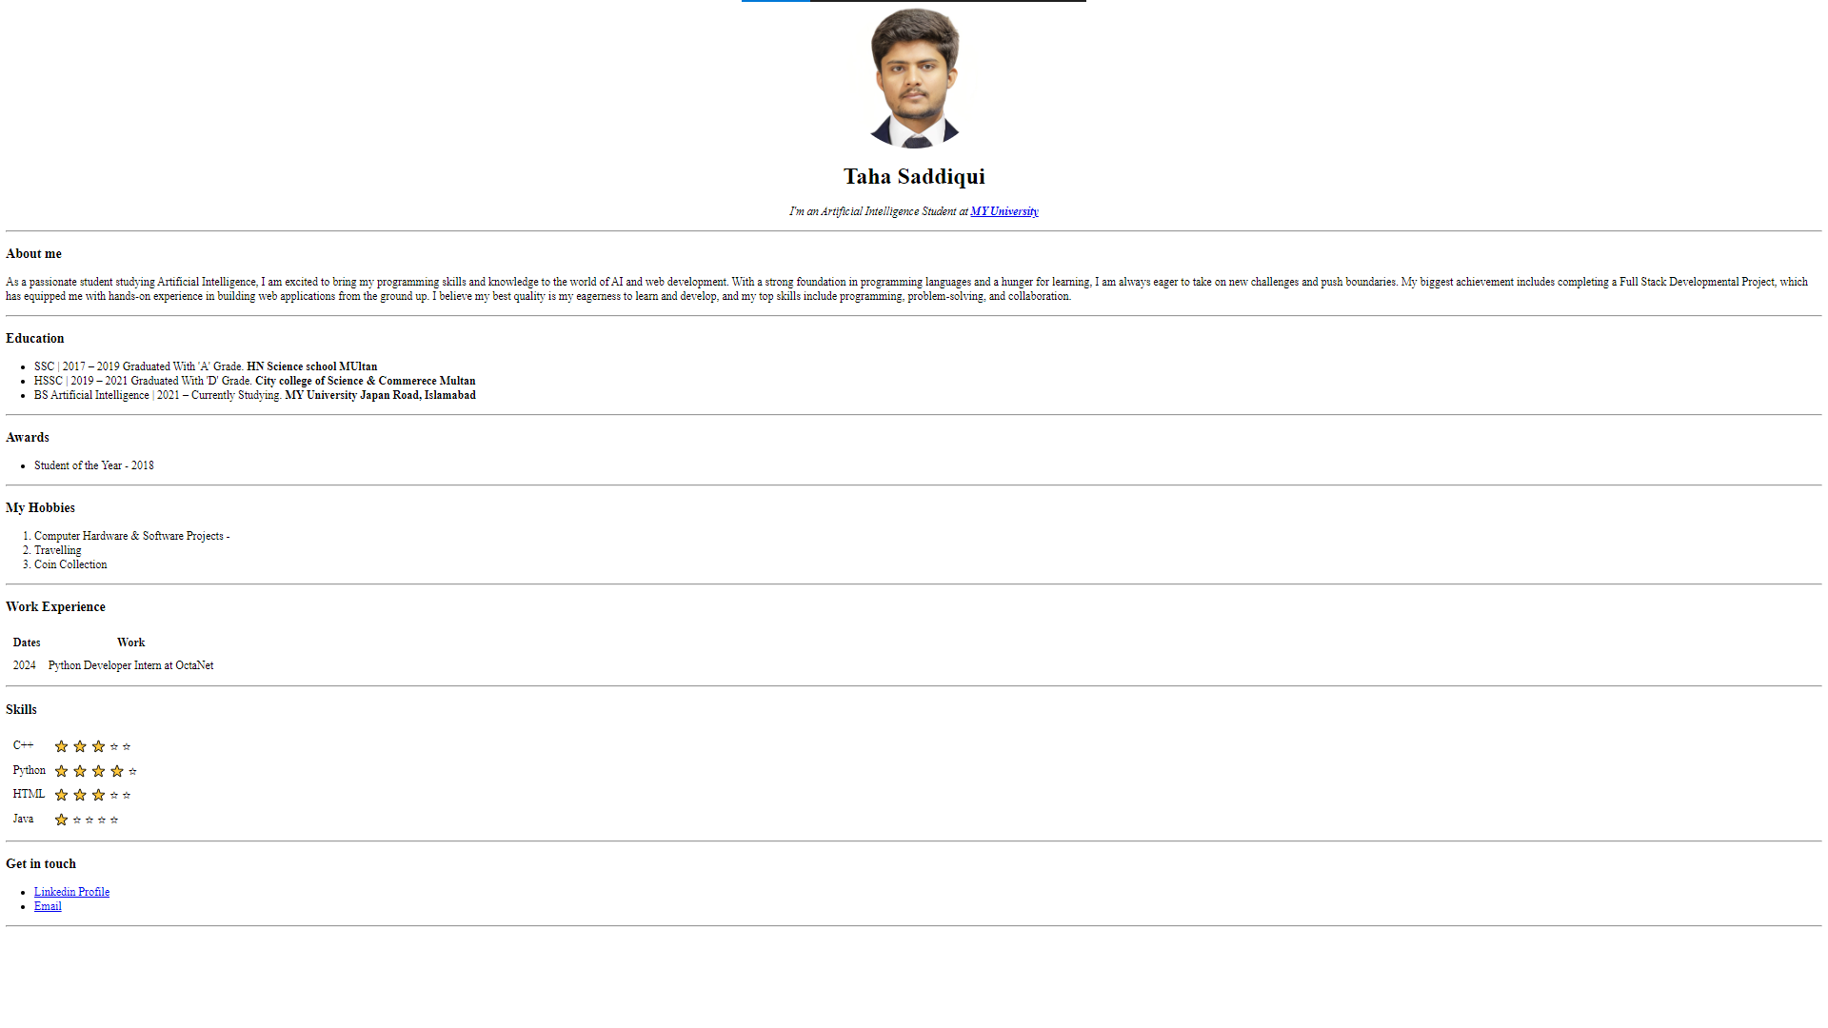**Output**

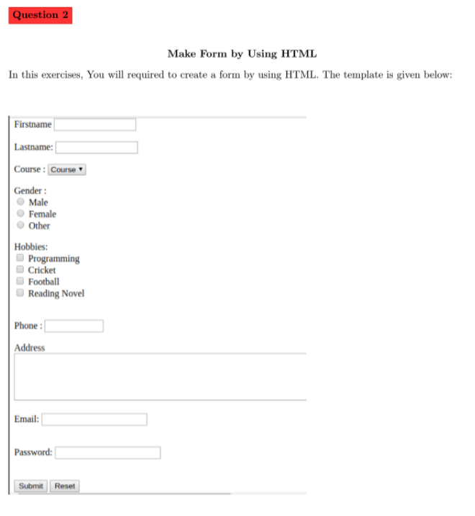

<!DOCTYPE html>

<html lang="enus">

<head>

 <meta charset="UTF-8">

 <meta name="viewport" content="width=device-width, initial-scale=1.0">

 <title>Taha Saddiqui Form</title>

</head>

<body style="font-family: Arial, sans-serif;">

 <div style="margin: 20px;">

 <form style="width: 300px; margin: 0;">

 <div style="margin-bottom: 10px;">

 <label for="firstname" style="display: inline-block; width:

100px;">Firstname:</label>

 <input type="text" id="firstname" name="firstname" style="width:

150px; padding: 5px; border: 1px solid #ccc;">

 </div>

 <div style="margin-bottom: 10px;">

 <label for="lastname" style="display: inline-block; width:

100px;">Lastname:</label>

 <input type="text" id="lastname" name="lastname" style="width:

150px; padding: 5px; border: 1px solid #ccc;">

 </div>

 <div style="margin-bottom: 10px;">

 <label for="course" style="display: inline-block; width:

100px;">Course:</label>

 <select id="course" name="course" style="width: 155px; padding:

5px; border: 1px solid #ccc;">

 <option value="course">Machine learning</option>

<option value="course1">Database</option>

<option value="course2">IOT</option>

 </select>

 </div>

 <div style="margin-bottom: 10px;">

 <label style="display: block; width: 100px;">Gender:</label>

 <label><input type="radio" name="gender" value="male"

style="margin-right: 5px;"> Male</label><br>

 <label><input type="radio" name="gender" value="female"

style="margin-right: 5px;"> Female</label><br>

 <label><input type="radio" name="gender" value="other"

style="margin-right: 5px;"> Other</label>

 </div>

 <div style="margin-bottom: 10px;">

 <label style="display: block; width: 100px;">Hobbies:</label>

 <label><input type="checkbox" name="hobbies" value="programming"

style="margin-right: 5px;"> Programming</label><br>

 <label><input type="checkbox" name="hobbies" value="cricket"

style="margin-right: 5px;"> Cricket</label><br>

 <label><input type="checkbox" name="hobbies" value="football"

style="margin-right: 5px;"> Travelling</label><br>

 <label><input type="checkbox" name="hobbies" value="reading"

style="margin-right: 5px;"> Reading Novel</label>

 </div>

 <div style="margin-bottom: 10px;">

 <label for="phone" style="display: inline-block; width:

100px;">Phone:</label>

 <input type="text" id="phone" name="phone" style="width: 150px;

padding: 5px; border: 1px solid #ccc;">

 </div>

 <div style="margin-bottom: 10px;">

 <label for="address" style="display: block;">Address:</label>

 <textarea id="address" name="address" rows="4" style="width: 100%;

padding: 5px; border: 1px solid #ccc;"></textarea>

 </div>

 <div style="margin-bottom: 10px;">

 <label for="email" style="display: inline-block; width:

100px;">Email:</label>

 <input type="email" id="email" name="email" style="width: 150px;

padding: 5px; border: 1px solid #ccc;">

 </div>

 <div style="margin-bottom: 10px;">

 <label for="password" style="display: inline-block; width:

100px;">Password:</label>

 <input type="password" id="password" name="password" style="width:

150px; padding: 5px; border: 1px solid #ccc;">

 </div>

 <div style="text-align: left;">

 <input type="submit" value="Submit" style="padding: 5px 15px;

border: 1px solid #ccc; background-color: #f2f2f2; cursor: pointer;">

 <input type="reset" value="Reset" style="padding: 5px 15px; border:

1px solid #ccc; background-color: #f2f2f2; cursor: pointer;">

 </div>

 </form>

 </div>

</body>

</html>

**Output**

